Unit 3
ELECTRICAL SIGNAL PROCESSING AND DATA ACQUISITION
- Basic Op-amp characteristics
- High voltage gain
- High input impedance
- Low output impedance
- High common mode rejection ratio (CMRR)
- Small signal bandwidth
- Low output voltage swing
- Perfect balanced
- High slew rate
- Instrumentation Amplifier
The instrumentation amplifiers (IAs) are differential amplifiers with input buffer stages. Just like operational amplifiers (Op Amp), IAs can be used in a close-loop as gain blocks whose amplitude at the output is controlled by the feedback resistors. The main difference between Op Amps and IAs is the higher immunity of the IAs to the noise between the inputs (because of the subtraction of the signals).
The circuit diagram of instrumentation amplifier:
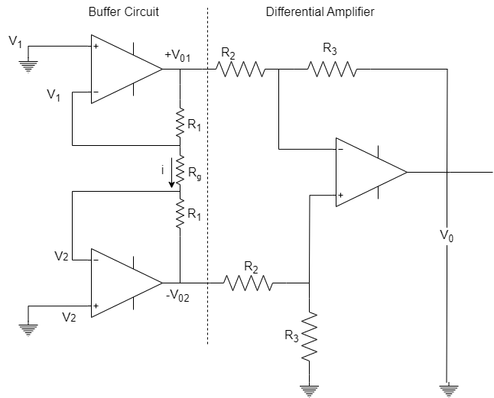

$$V_{0}=\frac{R_{3}}{R_{2}}\left[V_{02}-V_{01}\right]…………..\left(1\right)$$
$$Let, assume V_{1}>V_{2}$$
Some current passing through $V_{01}$ and $V_{02}$ path $i$current flowing through higher potential to lower potential.
$$i=\frac{V_{1}-V_{2}}{R_{g}}…………\left(2\right)$$
Assume, $V_{01}$ is higher potential to lower potential at $V_{02}$.
Applying the Ohm’s law
$$i=\frac{V}{R}=\frac{Voltage difference [V.D]}{Total resistance}$$
$$i= \frac{V_{01}-V_{02}}{R_{1}+R_{g}+R_{1}}=\frac{V_{01}-V_{02}}{2R_{1}+R_{g}}$$
$$\frac{V_{1}-V_{2}}{R_{g}}=\frac{V_{01}-V_{02}}{2R_{1}+R_{g}}$$
$$∴V_{01}-V_{02}=\frac{2R_{1}+R_{g}}{R_{g}}\left[V_{1}-V_{2}\right]$$
Taking ‘-ve’ sign common
$$V_{02}-V_{01}=\left[1+\frac{2R_{1}}{R_{g}}\right]\left[V_{2}-V_{1}\right]………(3)$$
Substituting equation (3) in equation (1)
$$∴V_{0}=\frac{R_{3}}{R_{2}}\left[1+\frac{2R_{1}}{R_{g}}\right]\left[V_{2}-V_{1}\right]$$
$$\frac{V_{0}}{V_{2}-V_{1}}=\frac{R_{3}}{R_{2}}\left[1+\frac{2R_{1}}{R_{g}}\right]$$
$$Gain=\frac{R_{3}}{R_{2}}\left[1+\frac{2R_{1}}{R_{g}}\right]$$
Advantages of Instrumentation Amplifier:
- Accurate and stable resistive feedback network to give a desired gain.
- Due to closed loop configuration used, so that instrumentation amplifier can use to directly for amplifier the signal by fixed amplification factor.
- CMRR specified which is only applicable for very low source impedance.
- Low DC offset, low noise, low drift high open loop gain, high slew rate, high input impedance.

- Signal amplification, attenuation, integration, differentiation, network isolation, wave shaping
Signal Amplification:
The signal amplifier is a circuit that used the electrical power to increase the amplitude of an incoming signal voltage or signal current output of this higher amplitude. The idea signal amplifier creates an extra replica of original signal that is larger but identical in every other way. In practice, a perfect amplifier is not possible.
Signal amplifier is an essential component of thousand of device like landline, cellular telephone, music and public address system, DAQ system, servomotor controller. In data acquisition system, signal amplifier need to increase the amplitude from transducer the output small signals sent to ADC. Some common signal amplifier in data acquisition systems;
- Voltage Amplifier
- High voltage amplifier
- Low voltage amplifier
- D.C. voltage amplifier
- A.C. voltage amplifier
- Current Amplifier
- Charge Amplifier
- Isolated Amplifier
- Differential Amplifier
- Strain Gauge Amplifier
- Bridge Amplifier
- Full bridge Amplifier
- Half bridge amplifier
- Quarter bridge amplifier
- Thermocouple Amplifier
Attenuation:
Attenuation, the opposite of amplifier is necessary when voltage to be digitized is beyond the ADC range. This form of signal conditioning decreases input signal amplitude so that conditioned signals is within ADC range. Attenuation is typically necessary when measuring voltage that is more than 10V.
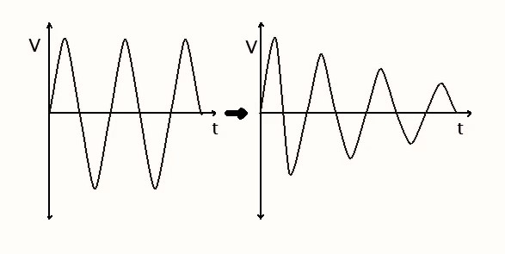
Attenuation is one of the techniques used in signal conditioning to scale down the amplitude or voltage level of a signal to match the input range or requirement of downstream components or systems. Attenuation can be achieved using passive or active components within a signal conditioning circuit.
- Active attenuation
It involves the use of active components such as the operational amplifier to actively amplify or attenuate the signal. In case of attenuation, an operational amplifier can be configured as an inverting amplifier or a voltage follower with appropriate gain settings to achieve the desired signal reduction.
Attenuation in signal conditioning is often used to protect sensitive component from excessive signal levels, prevent signal clipping or saturation or match signal level between different stages of the system, i.e. A/D converters where input voltage range is limited, attenuation can be applied to scale down the input signal to fit within the A/D range without losing important information.
- Passive attenuation
The passive attenuation techniques typically involve the use of voltage divider. The voltage divider circuit is commonly example of passive attenuation where output voltage is a fraction of the input voltage determined by the resistor values.
Integration:
An integrator is a circuit that performs a mathematical operation called integration. Integration is continuous addition. The most popular application of an integrator is to produce a ramp of output voltage which is linearly increasing or decreasing voltage. A circuit in which the output voltage is proportional to the integral of input voltage shown in figure below.
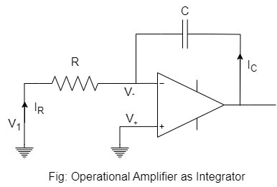
$$V_{+}=0$$
$$V_{+}-V_{-}=0$$
$$V_{-}=0$$
Applying the KCLL at node $V_{-}$
$$I_{R}+I_{C}=0$$
$$\frac{V_{1}}{R}+\frac{cdv_{0}}{dt}=0$$
$$\frac{cdv_{0}}{dt}=-\frac{V_{1}}{R_{1}}$$
$$\frac{dv_{0}}{dt}=-\frac{V_{1}}{R_{1}c}$$
Integrating on both sides;
$$\int{\frac{d\left(v_{0}\right)}{dt}}dt=\int{\frac{V_{1}}{R_{1}c}dt}$$
$$v_{0}=-\frac{1}{RC}\int{V_{1}}dt$$
The convenient values of $R_{1}$ and $C$ are MΩ and µF range.
Let, consider different types of input signal:
- Let $V_{in}=V_{m}\sin{ωt}$ $\left[∴sinwave\right]$
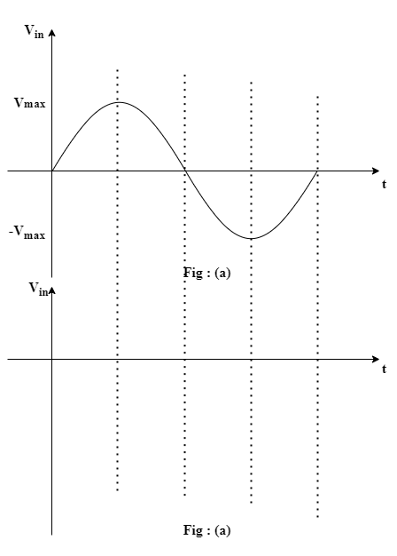
$-\frac{{2V}_{max}}{ω}$
$-\frac{V_{max}}{ω}$
- Let $V_{in}=step signal$
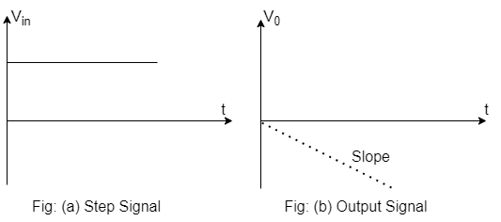

- $V_{in}=square wave$
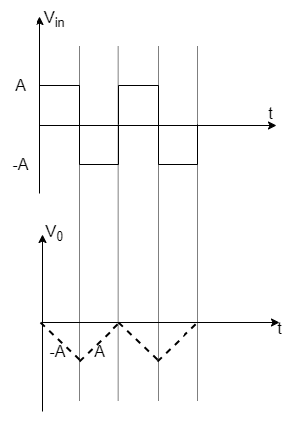
Differentiation:
It is function is to provide an output voltage proportional to the rate of change of input voltage. It is the inverses mathematical operation to that of an integrator. It also provides information about the instantaneous change in signal.
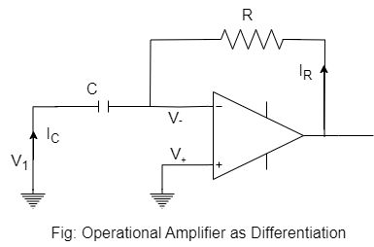
$$V_{+}=0$$
$$V_{+}-V_{-}=0$$
$$V_{-}=0$$
Applying KCL at node $V_{-}$
$$I_{C}+ I_{R}=0$$
$$\frac{cd\left[V_{1}\right]}{dt}+\frac{V_{0}}{R}=0$$
$$c\frac{d\left[V_{1}\right]}{dt}=-\frac{V_{0}}{R}$$
$$\frac{V_{0}}{R}=-c\frac{d\left[V_{1}\right]}{dt}$$
$$V_{0}=-RC\frac{d\left[V_{1}\right]}{dt}$$
The output voltage is equal to the differentiated input voltage. A differentiator is used in analog computer as it tends to amplify noise drift and other unwanted disturbance in the system.
Different types of input signal in differentiator circuit:
- Sine wave
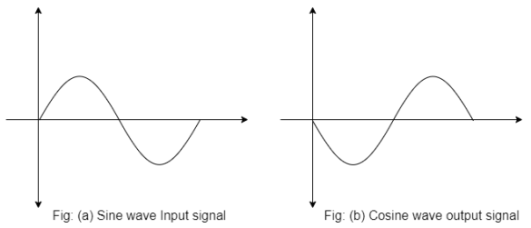

- Triangular wave
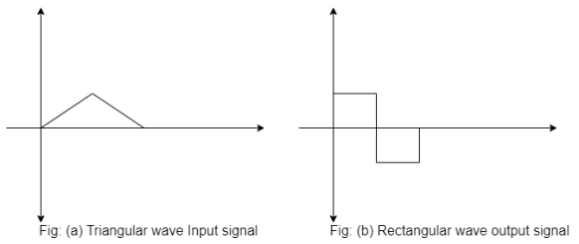

- Square wave
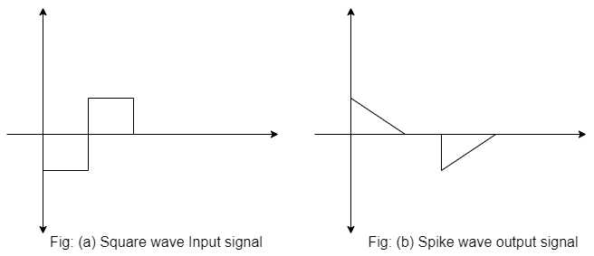
Network Isolation:
Network isolation refers to the practice of separating different parts of a computer network to prevent unwanted access or communication between them. There are several reasons why network isolation may be necessary:
- Security: Network isolation is often used to improve security by preventing unauthorized access to sensitive data or systems. By separating parts of a network into distinct segments, it can limit the scope of potential attackers and reduce the risk of a breach.
- Compliance: Many industries have specific compliance requirements for network security, such as HIPAA for healthcare or PCI DSS for payment card processing. Network isolation can help organizations meet these requirements by restricting access to sensitive data.
- Performance: Network isolation can also improve network performance by reducing congestion and optimizing traffic flow. By separating different types of traffic, such as voice or video, into distinct segments, it can ensure that each type of traffic receives the appropriate level of priority and bandwidth.
- Testing: Network isolation can also be useful for testing and development purposes. By creating isolated test environments, developers can safely test new applications or configurations without affecting the production environment.

Wave Shaping:
The process by which non-sinusoidal waveforms are altered in passing through circuit elements (such as diodes, resistors, inductors and capacitors) is called wave shaping. The wave shaping is used to perform any one of the following functions.
- To generate one wave from the other
- To limit the voltage level of the waveform to some preset level.
- To cut-off the positive and negative portions of the input waveform.
- To hold the waveform to a particular DC level.
The wave shaping is important in most of the signal process systems and is performed by the circuits known as differentiators, integrators, limiters, clippers and clampers
Types:
- Linear Wave shaping
The circuit, which makes use of only linear circuit elements such as the inductors, capacitors and resistors, are known as linear wave shaping circuits. Such circuits are used to perform functions of differentiation and integration.
- Non-linear Wave shaping
The linear wave shaping circuits contain only linear components like R, L and C. It is further divided as:
- Clipper:
A clipper is an electronic circuit that produced an output by removing a part of the input above or below a reference level. In other word, clipper circuit is electronic circuit that limits or clips the amplitude of a waveform at certain level. The clipper circuit is classified on the base of the clipping portion of the input.
- Positive Clipper
The positive clipper that clips the positive portion of the input signal.
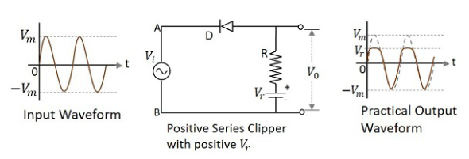

- Negative Clipper
A negative clipper is a clipper that clips only the negative portion of the input signal.
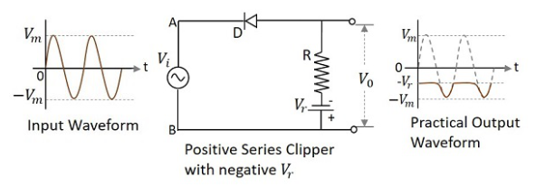
- Clamper:
A clamper circuit is a circuit that adds a DC levels to an AC signal. Actually, the positive and negative peaks of the signals can be placed at desired levels using clamping circuits. As DC level get shifted a clamper circuit is called as level shifter.
- Positive Clamper
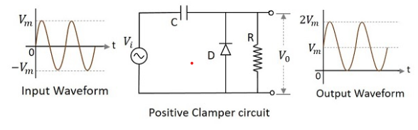
- Negative Clamper
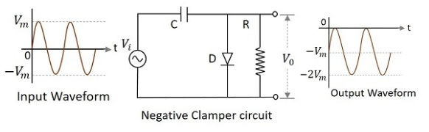

- Effect of noise, analog filtering, digital filtering
Effect of Noise:
Noise refers to unwanted or random signals that can interfere with the desired signal. In signal conditioning, noise can degrade the quality of the signal and make it more difficult to extract useful information. It can be arise from various sources, such as electromagnetic interference, thermal noise or limitation of electronic components.
The effect of noise omitted through the filter techniques, filter helps to reduce the impact of noise on the signal and improve its quality for further processing.
Analog Filter:
Analog filter involves the use of analog circuit such as, resister, inductor and capacitor to modify the characteristics at the signal. Analog filters are commonly used in signal conditioning to attenuate unwanted frequencies, remove noise, or sharp the frequency, response of the signal.
Analog filter can be designed as low-pass, high-pass, band-pass or band-reject filter to selectively allow or block certain frequency components of the signal. The undesired frequency components, including noise can be attenuated, improving the quantity for subsequent processing stage.
Digital Filtering:
It involves processing the signal in the digital domain using digital signal processing techniques. Digital filter are implemented through algorithms and computation performed by micro-processor, digital processor or dedicated hardware.
Advantages of Digital Filtering in Signal Conditioning:
- They provide flexibility in terms of filter characteristics and can easily modify.
- Digital filters can implemented a wide range of filter types including finite impulse response filter.
- Digital filtering allows precise control over filter parameters such as cut-off frequencies stop band attenuation and filter order.
- It enables efficient noise removal signal enhancement and frequency response shaping.
Overall, noise analog filtering and digital filtering all contribute to signal conditioning by reducing noise, improving signal quality and shaping the frequency responses need.
- Data Acquisition System
Data acquisition system may be defined as a system used for data processing, data conversion, data transmission and data storage. In other word, a data acquisition system is an information system that collect, stores and distributes of information. It is used in industrial and commercial electronics and environmental scientific equipment to capture the electrical signals or environment condition on computer device. A data acquisition system is also known as a data logger.
These data acquisition system will perform the tasks such as conversion of data, storage of data, transmission of data, processing of data for the purpose of monitoring analyzing or controlling the system and processes.
Data acquisition system instrument are the combination of a number of data acquisition components which make complete system or self-contained instruments.
Types of Data Acquisition System:
Data acquisition system is measurement system by which data is acquired economically and efficiently in desired form. Data acquisition system can be classified into following types which is given below:
- Analog Data Acquisition System
The data acquisition systems, which can be operated with analog signal are known as analog data acquisition system.
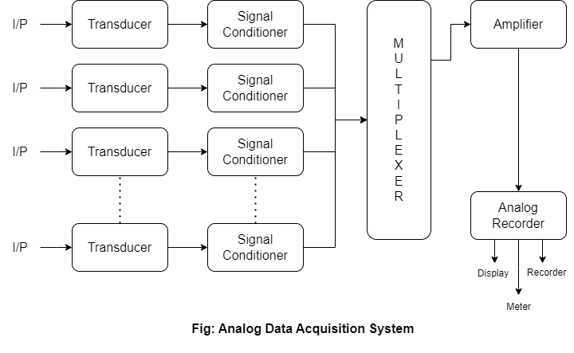
- Transducer
It converts the physical quantities into electrical signals one form of energy to another form of energy i.e. Non-electrical signal to electrical signal such as voltage or current.
- Signal Conditioner
It takes output from the transducer and makes it into suitable form of condition and desired signal sending to multiplexer.
- Multiplexer
Multiplexer is the process of showing single channel with more than one input and multiplexer accept multiple analog input and connects the sequentially to one measuring output. Multiplexing use same transmission channel for transmitting more than one quantity. It becomes necessary if distance between transmitting and receiving point is large and many quantities are to be transmitted by separate channel.
- Amplifier
An amplifier is increasing the power of signal or amplitude of the signal an input terminals than output terminals greater produces the amplitude signal in output terminals. An amplifier circuit is power gain greater than one.
- Analog Recorder/Device
It displays the input signal for monitoring purpose;
- Display: Displays the input analog data.
- Meter: Reads the analog input value.
- Recorder: Records the input analog data permanently

- Digital Data Acquisition System
The data acquisition systems, which can be operated with digital signals, are known as digital data acquisition system. So, that they use digital components for storing or displaying the information.
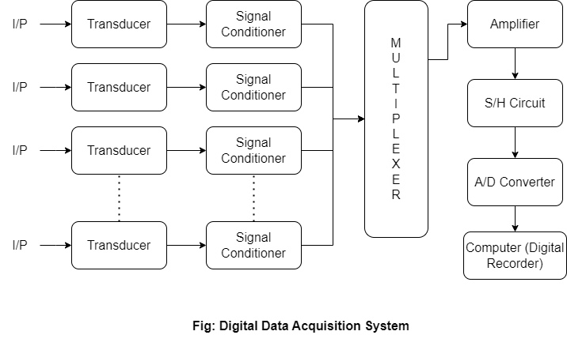
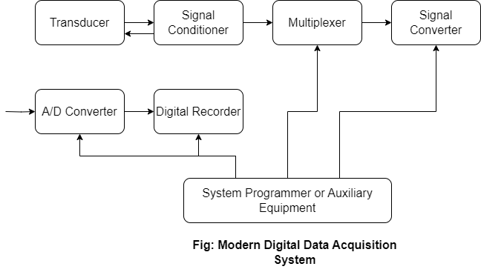
Digital data acquisition system [DAS] components:
- Transducer
It is converted non-electrical quantities [signal] to electrical signals or it can say physical quantities to electrical signal.
- Signal Conditioner
It performs the function like amplification and selection of desired signal.
- Multiplexer
In connects one of the multiple input to output so its acts as parallel to serial converter.
- Sample and Hold Circuit
It is usually used with an analog to digital converter to sample the input analog signal and hold the sampled signal, hence the name ‘Sample and Hold’. In the sample and hold circuit, the analog signal is sampled for short interval of time, [1µs to 10µs range]. After this, the sampled value is hold until the arrival of next input signal to be sampled. The duration of holding the sample will be usually milliseconds to few seconds.
The sampled value when provided to the ADC, it generates a discrete signal from an analog signal.
- A/D Converter
It converts to analog input to digital outputs.
- Digital Recorder/ Computer
It is used to record the data in digital format.

- Single Channel Data Acquisition System
The system consists of a ‘signal conditioner’ followed by an analog to digital converter [A/D] performing resistive conversions at a free running, internally determined rate.
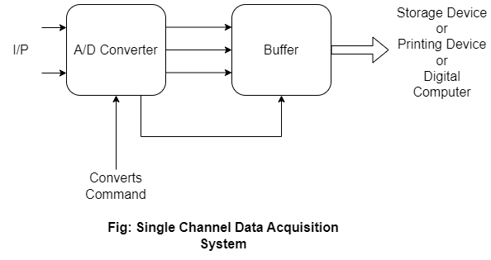
The digital outputs from the buffer are further fed to a storage or printout device or to a digital computer for analysis. For example: Digital panel meter [DPM]. A/D converter based on dual slope conversion techniques, useful for low from frequency data. Successive approximation the A/D converter also has high resolution and high speed. For signal level which is low compared to input requirements, amplification may be used in order to bring up the level of the input. Amplification is done by amplifier by single ended input or differential input.

- Multi-channel Data Acquisition System
There will be many sub-system in a data acquisition system can be time-shared by two or more input sources. Based on the derived properties of the multiplexed system a number of techniques are employed for such time-shared measurements.
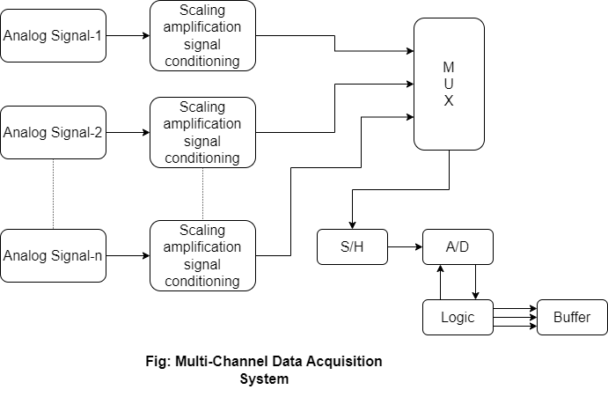
The output of transducer given to signal conditioning circuit and from output of signal conditioning circuit signal goes to multiplexer. The multiplexer output is converted into digital signals by A/D converter sequentially. The multiplexer stores data say of the first channel in the sample hold circuits. It is then seeks the second channel. During the interval the data of the first channel will be converted into digital form.
When once the conversion is complete, the status line from converter causes the sample-hold circuit return to the signal of the next channel. After acquisition of data either immediately or on a command the sample-hold circuit will be switched to hold-mode. Now conversion begins and the multiplexer selects the next channel.
This method is less costly, slow, sample and hold circuits or A/D converters are multiplexed for faster operations.

- PC Based Acquisition System
The most visible trends can be seen as the effects of transition to PC-base DAS [Data Acquisition System]. Now, all that processing is being done inside computers, so instruments are interfaced to a computer with analysis being done through computer software. Thus, we see a more software-defined approach to DAS, as well as the emergence of high-speed USB [Universal Serial Bus] enabled Data Acquisition System.
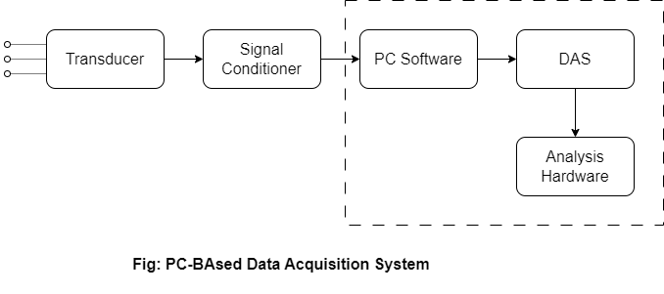
- Data Acquisition Hardware
The data acquisition hardware serves as the interface between physical signals and the computer. It is typically consists of analog to digital converter [ADC] for converting analog signals to digital data and digital to analog converters [DAC] for converting digital data into analog signals.
The various input or output channels for handling different types of signals [analog, digital, counter/time etc]. The hardware may also include signal conditioning components like amplifier, filter and isolation circuits to enhance the quality and reliability of the acquired signals.
- PC Interface
The data acquisition system hardware is connected to a computer via a suitable interface such as USB PCIe [Peripheral Component Interconnect Express], Ethernet or wireless connections. The interface enables the transfer of acquired data between the hardware and computer.
- Drive and Software
To communicate with the data acquisition hardware, the computer device drives and appropriate software. The device drives establish necessary communication protocols and provided an interface for accessing and controlling the hardware from the software applications.
The software typically includes development tools and libraries that facilitates data acquisition, signal processing, and visualization and analysis.
Benefits of PC-based Data Acquisition System:
- Versatility: Ability to utilize a wide range of software and hardware option.
- Processing Power: PCs provide ample computing power for real-time signal processing analysis and visualization.
- Integration: PC-based data acquisition system can easily integrate other software and hardware components making them suitable for complex measurement and control systems.
- Cost Effectiveness: It is more cost-effective.

- Series and Parallel Transmission
The process of sending data between two or more digital devices is known as data transmission. It is divided as follows:
- Serial Transmission
In serial transmission, data bit flows from one computer to another computer in bi-direction. In this transmission, one bi flows at one-clock pulse.

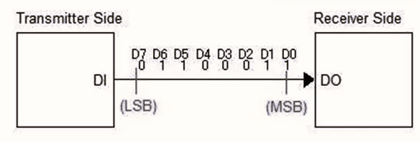
It can be further divided as:
- Synchronous Transmission
- Asynchronous Transmission
- Isochronous Transmission

- Parallel Transmission
In parallel transmission, many bits are flow together simultaneously from one computer to another computer. Parallel transmission is faster than serial transmission to transmit the bits. Parallel transmission is used for short distance.
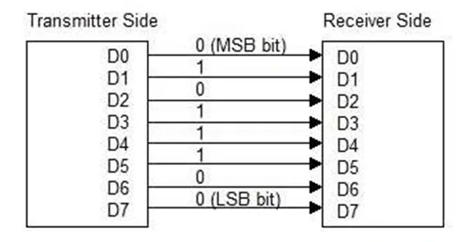
3.6.1 Features and Applications of RS232 Cable
RS-232 [Recommended Standard-232] is a type of serial communication used for transmission of data normally in medium or long distances. It is used for connecting computer and its peripheral device to allow serial data exchange between them. As its path data exchange between them, it is used to serial communication up to 50 ft. with rate of 1.49kbps. For EIA [Electronics Industry Association] defined, the RS-232 used for connecting DTE [Data Transmission Equipment] and DCE [Data Communication Equipment]
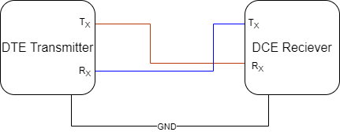
RS-232 Features:
- RS-232 uses Asynchronous communication so, no clock pulse is shared between PC and MODEM.
- Logic 0 pin is started voltage range high. Let, +12V, logic-1 pin is started range low. Let assume range -12V.
- Maximum 232 IC can install easily to establish RS-232 interface with microcontrollers.
- Full-duplex interface of RS-232 is very convenient.
- Two pin simplex RS-232 interface can also established.
- A maximum data transfer speed of 19kbps is possible through RS-232.
- A maximum current of 500mA can be drawn from pin of RS-232.
Applications of RS-232
- Serial communication between computers and peripherals such as MODEMs, printers, Barcode scanners and industrial control device.
- Configuration and programming devices including routers, switches, network devices and embedded systems.
- Data acquisition and instrumentation used for connecting data acquisition devices such as sensors, data loggers and measuring instruments to a computer or control system.
- Industrial automation and control to enable communication between programmable logic controllers [PLCs], Human-M/C interfaces [HMIS] and other control devices.

3.6.2 Features and Applications of IEEE 1248 B
IEEE 1248-2020 is titled “Standard for Analog to Digital Converter [A/D] Testing-Methods and Metrics”. This standard provides guidelines and methods for testing the performance of A/D converter in various applications.
Features of IEEE 1248-2020:
- A/D converters testing method: The various methods for evaluating the performance of A/D converter, including the testing of accuracy linearity, resolution, dynamic range and important parameters.
- Test Procedures: It converts aspects such as test setup, test signals, measurement techniques and data analysis.
- Performance Metrics: ADCs ability to convert analog signals into digital representation accurately.
- Reporting Requirements: IEEE 1248-2020 specifies the information that should be included in test reports to ensure clear and consistent documentation of ADC performance.

- Optical Communication, Fiber optics, electro-optic conversion devices
Optical Communication:
It is method for communication in which signal is transmitted in the form of light and optical fiber is used as a medium of transmitting and those light signal from one place to another place. The signal transmitted in optical fiber is converted from electrical signal to light signal from transmitting end to receiving end and it is converted back into the electrical signal from the light. The data sent in form of audio, video or telemetry data for long distance or local area network.
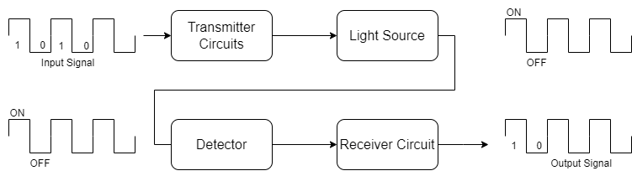
- Transmitter Side
First, if data is analog then it sent to be converter circuit which converts the analog signals into digital pulses of 0s and 1s form and passed through light source transmitter circuit. If the input signal is digital then it is directly sent to the light source circuit, which converts the signal in the form of light wave.
- Optical Fiber Cable
The light wave received from the transmitter circuit to the fiber optic cable is now transmitted from source location to destination and receiver blocks.
- Receiver Side
Now the receiver side photo cell, also known as light detector, receives the light waves from optical fiber cable, amplifies it using the amplifier and converts it into the proper digital signal. Now, if the output source is digital then the signal is not changed. If the output source need analog signal them the digital pulses are converted into analog signal by using converter or decoder circuit.
The whole process of transmitting an electrical signal from one point to other by converting it into light using fiber optic cable as transmission source is called optical fiber communication.
Fiber Optics:
Fiber optic involves transmission of light signals through optical fibers, which are typically made of glass or plastic. These fibers have the ability to guide light through multiple reflections, allowing for efficient and high speed transmission of data over long distances. The diameter of fiber optical cable is made of high quality extruded glass [Si] or plastic and it is flexible.
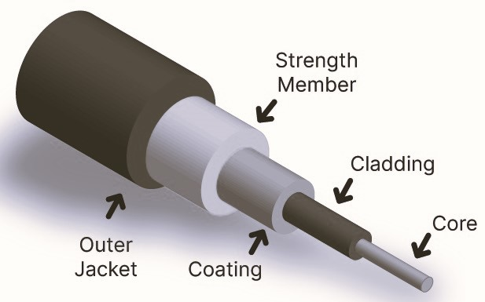
The diameter of fiber optical cable is in between 0.25mm to 0.5mm [Slightly thicker than human hair]
Features:
- Low Loss: Data to be transmitted over long distance without significant degradation.
- Large Transmission Capacity
- Easy Amplification
- High bandwidth allowing for transmission of large amounts of data simultaneously
- Immunity to Electromagnetic interference: Suitable use in environments with high electrical noise
- Light-weight and flexible: Make easy to install and for various applications.

Electro-optic Conversion Device:
Electro-optic conversion device is also known as opto-electronics devices, the essential components in optical communication systems. This device facilitates the conversion of electrical signal to optical signals and vice-versa.
Some commonly used electro-optic conversion device includes:
- Light Emitting Diodes (LEDs)
LEDs are used as light sources in optical communication systems. They convert electrical signal to light signals [infrared or visible spectrum].
- LASER Diodes
Laser diodes are another type of light source used in optical communication. They produced coherent and slightly focused light, making them suitable for long distance transmission.
- Photo Diodes
Photo diodes are used to convert optical signal back into electrical signals. They detect and convert light intensity variations into electrical current, allowing for signal detection and processing.
- Modulators
Modulators are device that modulate the intensity, phase or frequency of optical signal in response to an electrical signal. These electro-optic conversion device enable the transmission, reception and processing of data in optical communication systems. They are integrated into transmitter, receivers and other system components to ensure efficient and reliable communication.

